Image 1 :

Output -

Simple :

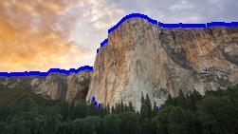

Viterbi :

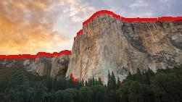

Human Input :

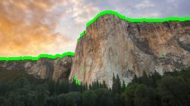

Image 2 :

Simple :

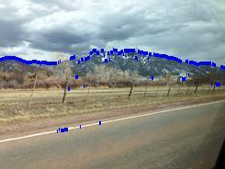

Viterbi:

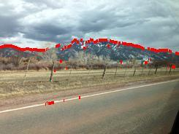

Human Input :

